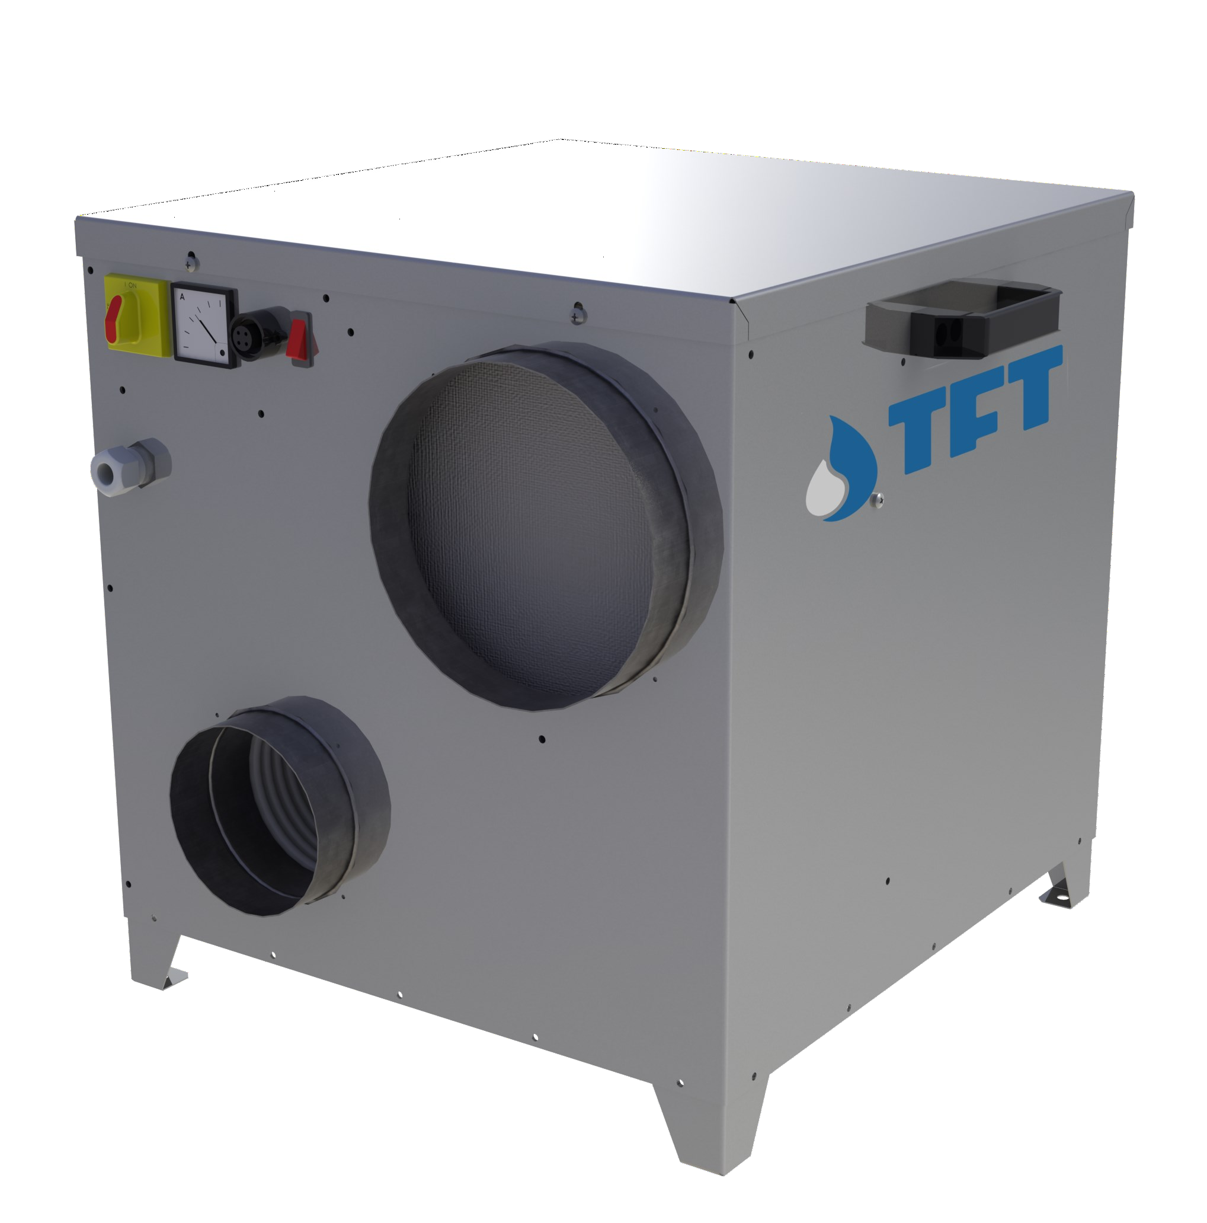

AIRDRY
Adsorption Dehumidifiers





TECHNICAL DATA
MODEL | AD | 150 | 300 | 450 | 600
Performances
Dehumidification Capacity * | Kg/h | 0,65 | 1,4 | 2,5 | 3,4
Fans
Process air flow | m³/h | 150 | 300 | 450 | 600
Static pressure | Pa | 100 | 120 | 150 | 120
Fan nominal power | W | 60 | 60 | 140 | 140
Reactivation air flow | m³/h | 50 | 100 | 150 | 200
Static pressure | Pa | 100 | 100 | 50 | 100
Fan nominal power | W | 85 | 85 | 170 | 170
Drive Motor
Nominal power | VA | 3,7 | 3,7 | 3,7 | 3,7
Regeneration
Regeneration type |  | Electric | Electric | Electric | Electric
Installed power | KW | 1,4 | 2,1 | 4,2 | 6,0
Temperature rise in the heating coil | °C | 80 | 80 | 80 | 80
Electrical characteristics
Power supply | Volt/Ph/Hz | 230/1/50 ±5% | 230/1/50 ±5% | 230/1/50 ±5% | 400/3+N/50 ±5%
Maximum power absorbed standard units | KW | 1,54 | 2,24 | 4,51 | 6,31
Maximum current absorbed standard units | A | 6,9 | 9,9 | 19,8 | 9,8
Noise level
Sound pressure ** | dB (A) | 42 | 42 | 44 | 44
Sound power ** | dB (A) | 70 | 70 | 72 | 72
* Conditions at 20°C 60% RH
** Sound pressure level calculated in free field, 10 meters from unit, direction factor Q = 2, according to ISO 9614

DEHUMIDIFICATION CAPACITY
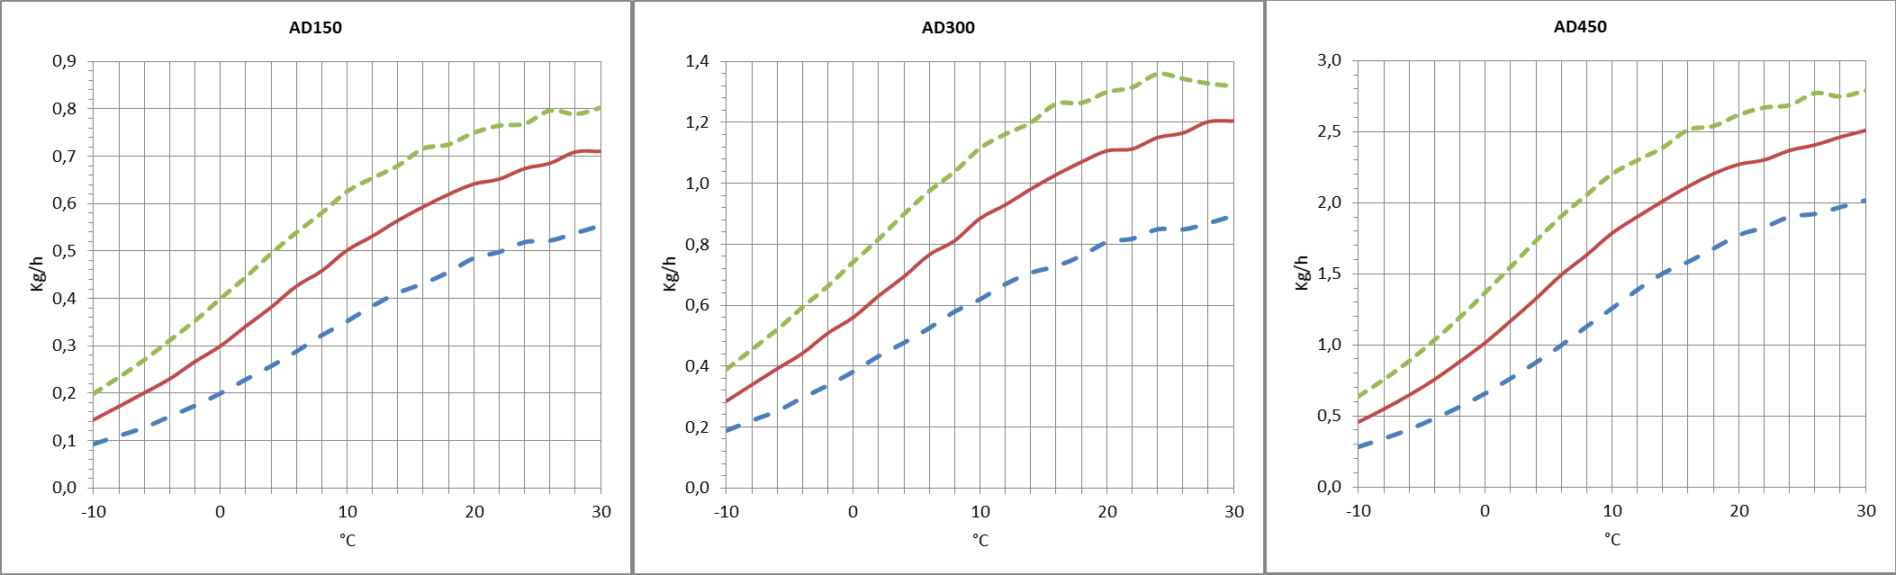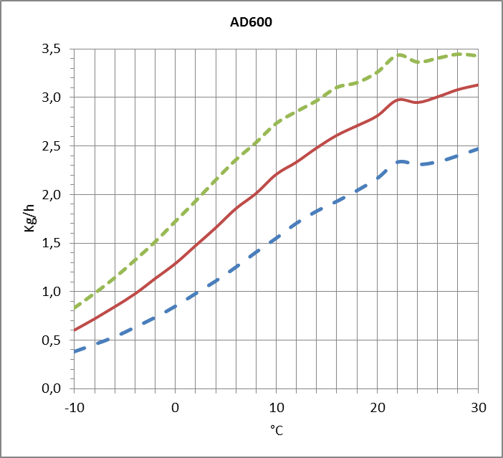Approximate capacity in Kg/h with different relative humidity values of inlet process air (RH%).

TECNOFRIGO TUSCANY srl
Via J.F.Kennedy, 25-27-29
56020 Capanne (Pisa)
+39 0571 467351

PRINCIPLE OF OPERATION
WWW.TFTDRYAIR.COM INFO@TFTDRYAIR.COM

CEN0106 issuance 12.16
Subject to change without notice
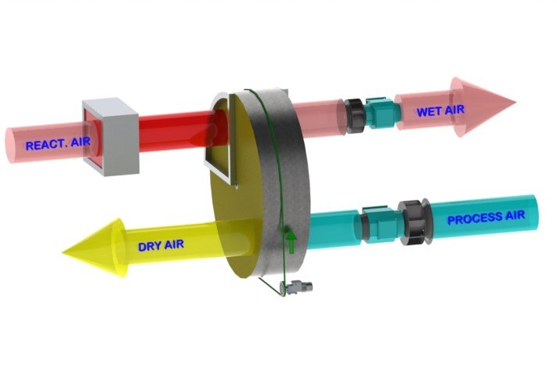
The dehumidifier operates with 2 airflows. The main airflow, the PROCESS AIR is what is dehu- midified and a second, smaller, airflow is used to regenerate the rotor material. Two high effi- ciency fan and motor assemblies inside the machine create these separate airflows in opposite directions through the rotor. The PROCESS AIR is taken trough the dehumidification rotor and moisture is taken up by the desiccant material bonded to the rotor structure. Mainly Silica Gel is used, which is a hygroscopic material capable of holding many times its weight in moisture, but always as a vapour and with no free water. As it passes through the rotor, the moisture in the air is absorbed by the Silica Gel and sent from the machine as a dry air stream for onward proces- sing, or direct to a conditioned room as required.
This dehumidification process is reliable between extremes of temperature, from as low as
-30°C and as high as +40°C.
During the process the rotor is turned very slowly by a small motor and reduction gearbox, dri- ving a belt with friction contact direct to the rotor surface.
The separate REGENERATION AIR stream is taken through the dehumidifier in the opposite direction, through a heater bank where the temperature is raised typically by +100°C above ambient. This heating increases the capacity of the air to hold moisture and as a result of the vapour pressure differentials between this air stream and the rotor surface, moisture is given back to the regeneration air stream and passed out of the building as a vapour.
The rotor is then ready to absorb more moisture as it is turned and the whole process can continue.

STRUCTURE
The structure of the dehumidifier is made of galvanized steel and steel AISI_304. The top panel can be removed for maintenance on electrical compo- nents and all other internal mechanical parts. The dehumidifier connections can be made with standard spiral ducts.

FANS
Fans are directly coupled to single-phase or three-phase motors rated at IP55, ISO F, class B. They are accessible for maintenance by removing the inspected top panel. The process and regenerator fans immediately start to dehumidify the system.

ROTOR
The desiccant rotor installed in the dehumidifier is the best currently available to the market, offering approximately 8% better moisture removal capacity and 25% less air pressure drop than the leading competitor. The rotor has a finely fluted structure manufactiured from corrugated and heat resistant material and offering a huge contact surface area for the process air stream in a very small volume. The fluted and laminar nature of the structure af- fords a high contact area with the passing air flow to maximise moisture removal.
The rotor is not affected by saturated air and can therefore be used in conjunction with a pre-cooling coil. Additionally, the rotor will not be damaged if either of the airflows stop for any reason. The rotor does not shed particles and will not support the spread of flame (non-combustible).

TRANSMISSION SYSTEM
A belt drive system is used to turn the rotor. This movement is typically between 6 and 12 rph, and uses a powerful direct drive motor and reduction gearbox, operating on a belt with frictional contact with the outer rim of the rotor drum. A belt tensioning system is used to maintain correct belt tension and avoid slip. The rotation of the rotor is visible by removal of the front access panel so correct operation can be determined. The rotor is suspended on ball bearings around a central steel shaft.

REGENERATION AIR HEATING COIL
Electrical. The electric regeneration battery has self-regulating PTC elements, with modulating power system to increase the efficiency of the dehumidi- fier field and save energy.

FILTERS
The dehumidifier has two separate G2 filters: on the process air and regeneration air inlet.

ELECTRICAL PANEL
The electric panel is made in compliance with European regulations 73/23 and 89/336. Access to the electrical panel is possible by removing the top panel of the unit. In all units, the following components are installed as standard: main switch, ammeter, external connection humidifier connector. The panel is also equipped with a switch for manual or automatic dehumidification control.

VERSION
AD… Standard
AD…/M01 Construction version, with pivoting wheels and working hour meter

Model AD | Code | 150 | 300 | 450 | 600
Painted steel frame |  | - | - | - | -
Satin stainless steel frame 304 |  | ● | ● | ● | ●
Construction site version with pivoting wheels | M01 | ○ | ○ | ○ | ○
Main power switch |  | ● | ● | ● | ●
Frame Handed version | M | - | - | - | -
Filters G2 process and reactivation |  | ● | ● | ● | ●
Filters F5, F7, F9 |  | - | - | - | -
Electronic PLC control and touch-screen terminal |  | - | - | - | -
Remote terminal | TR | - | - | - | -
Different power supply voltage |  | ○ | ○ | ○ | ○
Proportional control PWM regenerationheaters | PWM | - | - | - | -
Process filter alarm | ALFP | - | - | - | -
Regeneration filter alarm | ALFR | - | - | - | -
Mechanical humidistat for duct 30÷100% IP65 1 step | ADKM1 | ○ | ○ | ○ | ○
Mechanical humidistat for duct or wall 10÷100% IP54 1 step | ADKMH1 | ○ | ○ | ○ | ○
Mechanical humidistat for duct or wall 10÷100% IP54 2 steps | ADKMH2 | ○ | ○ | ○ | ○
Mechanical humidistat for wall 2 steps with duct probe temperature /  relative humidity range -30÷70°C / 0÷100% | ADKW + ADKH1 | ○ | ○ | ○ | ○
Electronic humidistat for wall 2 steps with duct probe temperature /  relative humidity range NTC / 10÷90% | ADKW + ADKH2 | ○ | ○ | ○ | ○
Electronic humidistat for wall 2 steps with wall probe temperature /  relative humidity range NTC / 10÷90% | ADKW +  ADKH3 | ○ | ○ | ○ | ○
- standard, ○ optional, – not available.

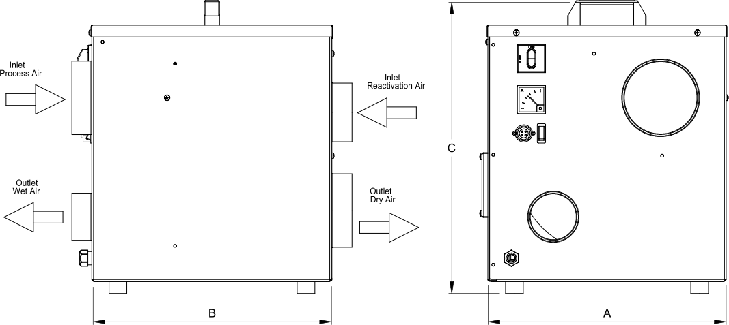
Dimensions

Model | AD | 150 | 300 | 450 | 600
A | mm | 335 | 415 | 570 | 570
B | mm | 375 | 415 | 510 | 510
C | mm | 420 | 500 | 510 | 480
Empty weight | Kg | 17 | 23 | 32 | 36
Connections
Process air inlet | mm | Ø 125 | Ø 160 | Ø 160 | Ø 200
Dry air outlet | mm | Ø 100 | Ø 160 | Ø 160 | Ø 200
Reactivation air inlet | mm | Ø 100 | Ø 125 | Ø 125 | Ø 160
Wet air outlet | mm | Ø 80 | Ø 100 | Ø 100 | Ø 125

TECNOFRIGO TUSCANY srl WWW.TFTDRYAIR.COM
Via J.F.Kennedy, 25-27-29 INFO@TFTDRYAIR.COM
56020 Capanne (Pisa)
+39 0571 467351 CEN0106 issuance 12.16
Subject to change without notice

