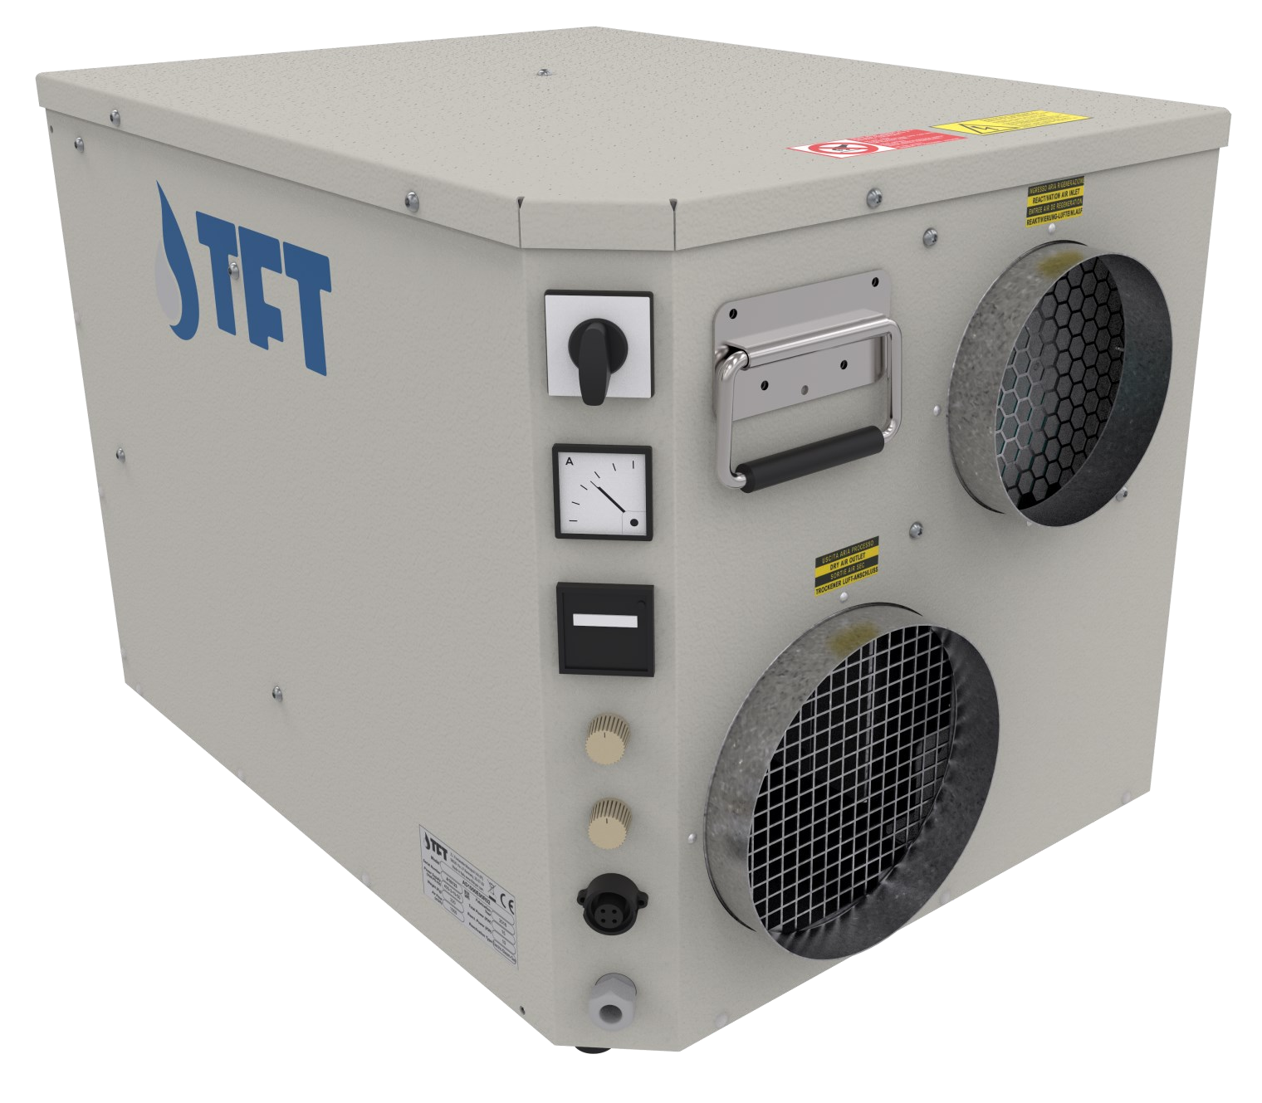

AIRDRY
Adsorption Dehumidifiers





TECHNICAL DATA
MODEL | AD | 100 | 270 | 420 | 550 | 700 | 820 | 1250
Performances
Dehumidification Capacity * | Kg/h | 0,59 | 0,99 | 1,95 | 2,67 | 2,71 | 4,78 | 6,74
Fans
Process air flow | m³/h | 100 | 270 | 420 | 550 | 700 | 820 | 1250
Static pressure | Pa | 180 | 210 | 300 | 270 | 180 | 160 | 400
Fan nominal power | W | 52 | 102 | 166 | 166 | 170 | 170 | 500
Reactivation air flow | m³/h | 30 | 50 | 90 | 120 | 135 | 210 | 270
Static pressure | Pa | 210 | 190 | 320 | 280 | 260 | 250 | 180
Fan nominal power | W | 80 | 80 | 166 | 166 | 166 | 166 | 166
Drive Motor
Nominal power | W | 3,0 | 3,0 | 3,0 | 3,0 | 3,0 | 3,0 | 3,0
Regeneration
Regeneration type |  | Electric | Electric | Electric | Electric | Electric | Electric | Electric
Installed power | KW | 0,9 | 1,3 | 2,6 | 3,5 | 3,5 | 6,6 | 9,9
Temp. rise in the heating coil | °C | 80 | 75 | 80 | 85 | 75 | 90 | 100
Electrical characteristics
Power supply | Volt/Ph/Hz | 230/1/50 | 230/1/50 | 230/1/50 | 230/1/50 | 230/1/50 | 400/3+N/50 | 400/3+N/50
Maximum power absorbed | KW | 1,04 | 1,49 | 2,94 | 3,84 | 3,84 | 6,95 | 10,58
Maximum current absorbed | A | 4,52 | 6,48 | 14,03 | 17,92 | 17,93 | 12,33 | 17,95
Noise level
Sound pressure ** | dB (A) | 42 | 42 | 44 | 44 | 46 | 58 | 64
Sound power ** | dB (A) | 70 | 70 | 72 | 72 | 74 | 86 | 92
* Conditions at 20°C 60% RH
** Sound pressure level calculated in free field, 10 meters from unit, direction factor Q = 2, according to ISO 9614

DEHUMIDIFICATION CAPACITY
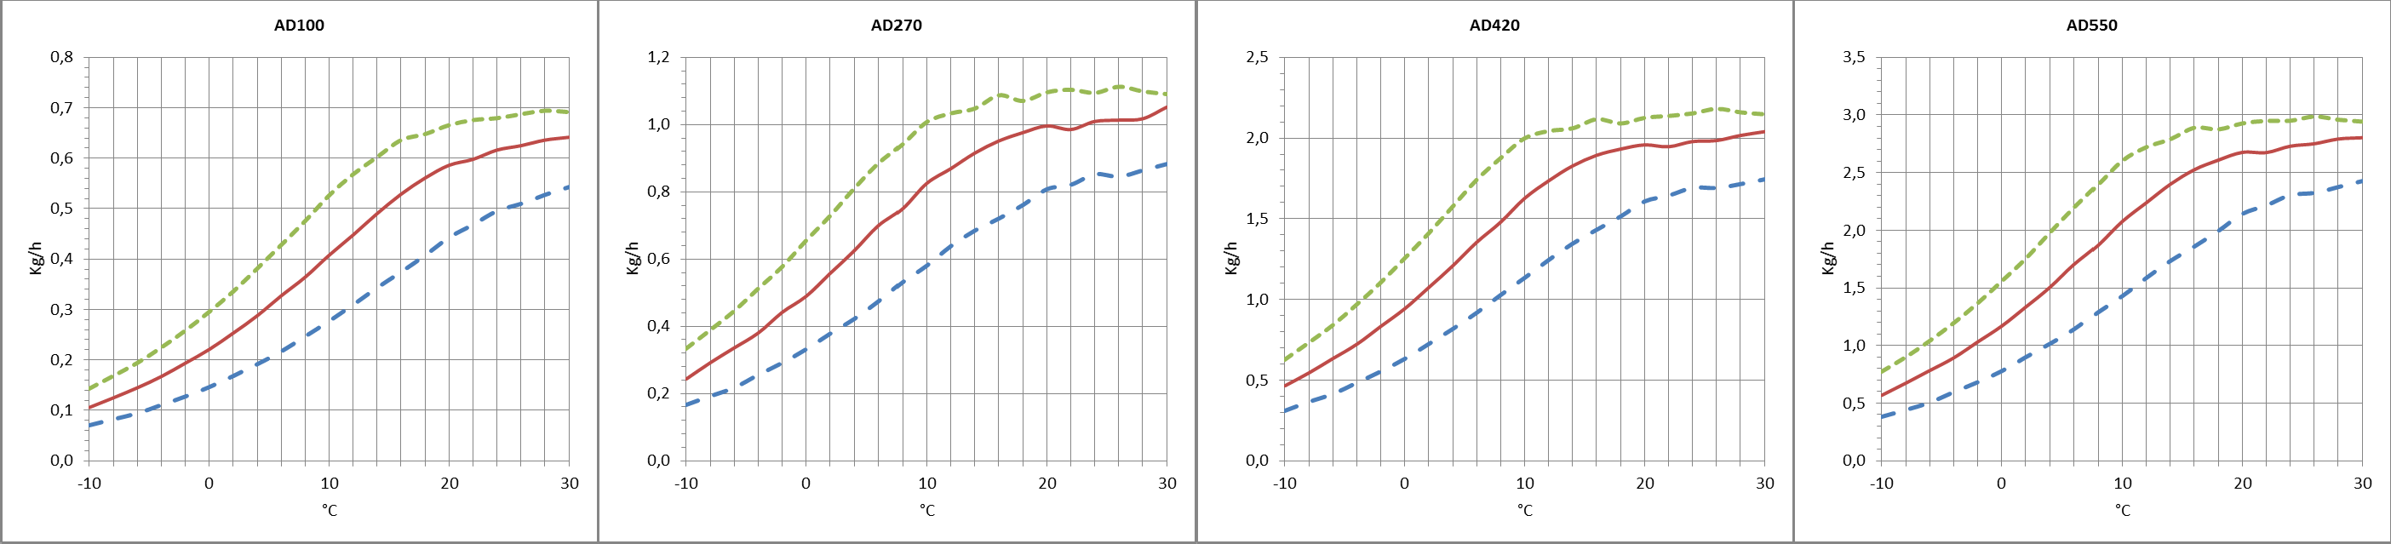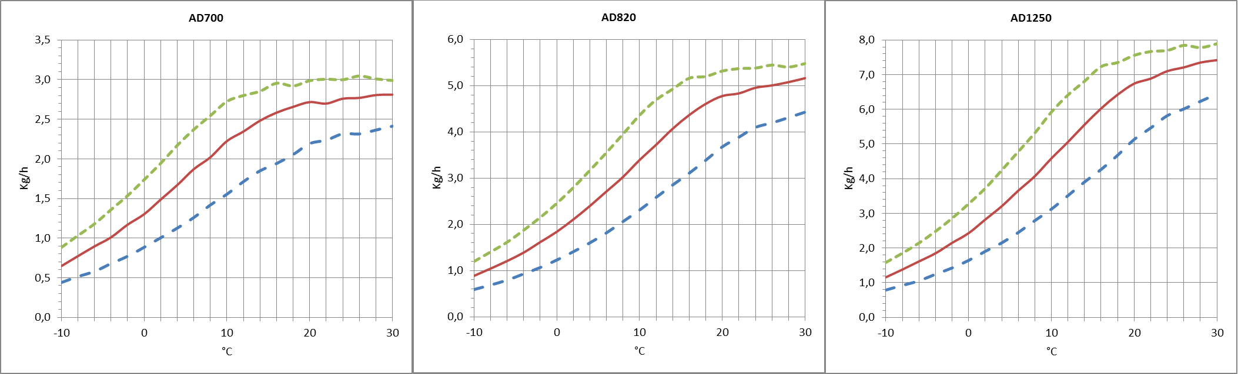Approximate capacity in Kg/h with different relative humidity values of inlet process air (RH%).

TECNOFRIGO TUSCANY srl
Via J.F.Kennedy, 25-27-29
56020 Capanne (Pisa)
+39 0571 467351

PRINCIPLE OF OPERATION
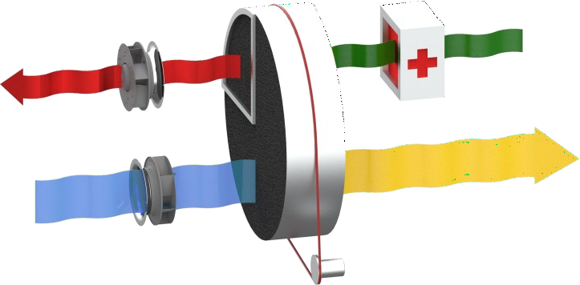
The dehumidifier works by using two air flows; the main one is the air to dehumidify, a second flow - of smaller flow rate - is used to regenerate the dehumidification rotor. Two fans inside the dehumidifier create these two air flows that pass through the rotor in opposite directions. The air to be dehumidified, also called "process air", passes through the silica gel impregnated desic- cant rotor. Silica gel is a highly hygroscopic material that absorbs water vapour from the air. As the air passes through the rotor, it transfers its moisture content to the rotor. The dehumidified air is then sent to the production room or process to be dehumidified. The dehumidification pro- cess can take place between -30°C and +40°C. During the process the rotor rotates very slowly and is equipped with a drive system with reduction gear and belt. The so-called "regeneration air" is used by the system to remove the absorbed humidity and take it outside: it is heated by a battery inside the dehumidifier, up to about +100°C and passes through the rotor in the opposite direction to the process air and subjects it to a reverse process, for which the rotor gives up its moisture content and its initial absorbing capacity is restored. The regeneration air is expelled lukewarm and humid and must be sent out of the treated environment.

STRUCTURE
The structure of the dehumidifier is made of galvanized steel painted on the outside. The top
panel can be removed for maintenance to electrical components and all other internal mechanical parts. The connections to the dehumidifier can be made with standard spiral channels.

FANS
The fans are directly coupled to a single-phase AC or EC motor of class IP55, ISO F, Class B. They are accessible for maintenance by removing the upper inspection panel. The process and regeneration fan starts immediately when the dehumidifier is energized and can be adjusted manually by means of a potentiometer located on the front of the structure (available from model AD420 onwards).

ROTOR
The dehumidifier has a rotor made of desiccant material. The rotor has a honeycomb structure made of corrugated, heat-resistant sheets containing silica gel desiccant material, which creates a high number of axial fluid threads and at the same time a high absorption surface in a small volume. The rotor is constructed to withstand saturated air without being damaged. In addition, the rotor is not damaged if the process or regeneration fan should stop due to malfunction during operation. The rotor is non-combustible and non-flammable.

TRANSMISSION SYSTEM
A belt drive system controls the movement of the rotor. The belt carries out its pulling action on the outer edge of the rotor and is guided by a pulley on the gear motor. A special device maintains the correct belt tension to prevent belt slippage. The correct direction of rotation and transmission can be checked by opening the top panel. The rotor is equipped with ball bearings. The rotor shaft is made of steel.

REGENERATION AIR HEATING COIL
Electrical. The electric regeneration battery is of the self-regulating PTC type, to keep the surface temperature constant.

FILTERS
The dehumidifier has a G3 filter: on the process and regeneration air inlet.

ELECTRICAL PANEL
The electrical panel is manufactured in compliance with European standards 73/23 and 89/336. Access to the electrical panel is possible by removing the top panel of the unit. The following components are installed in all the units: main switch, ammeter, hour meter and connector for connection of the external humidistat. An energy meter can also be fitted as an option. The panel is also equipped with a switch for manual or automatic control of the dehumidification management and it is possible to configure the mode with continuous operation of the process fan even when humidity is reached (with humidistat connected and in automatic operation).

WWW.TFTDRYAIR.COM INFO@TFTDRYAIR.COM

CEN0112 issuance 07.20

VERSION
AD… Standard
AD…/HR Version with heat recuperator for regeneration air (50%-80% recovery).

Model AD | Code | 100 | 270 | 420 | 550 | 700 | 820 | 1250
Painted steel frame |  | ● | ● | ● | ● | ● | ● | ●
Satin-finish stainless steel304 frame |  | ○ | ○ | ○ | ○ | ○ | ○ | ○
Cover box for outdoor installation | ADKOPB | ○ | ○ | ○ | ○ | ○ | ○ | ○
Heat recovery regeneration air | /HR | ○ | ○ | ○ | ○ | ○ | ○ | ○
Process and regeneration air flow rate regulator |  | - | - | ● | ● | ● | ● | ●
Turbo box for increased pressure available process air | ADKTBP | ○ | ○ | ○ | ○ | ○ | ○ | -
Turbo box for increased pressure available regeneration air | ADKTBR | ○ | ○ | ○ | ○ | ○ | ○ | ○
Main power switch |  | ● | ● | ● | ● | ● | ● | ●
Frame in mirror version | M | - | - | - | - | - | - | -
G3 filters process and regeneration |  | ● | ● | ● | ● | ● | ● | ●
Filters F5, F7, F9 |  | - | - | - | - | - | - | -
PLC electronic control and touch-screen terminal |  | - | - | - | - | - | - | -
Different supply voltage |  | ○ | ○ | ○ | ○ | ○ | ○ | ○
Process air filter clogged | ALFP | - | - | - | - | - | - | -
Regeneration air filter clogged | ALFR | - | - | - | - | - | - | -
Electronic wall-mounted humidistat 2 steps | ADKHW+ | ○ | ○ | ○ | ○ | ○ | ○ | ○
Duct (D) or wall (W) probe temperature / relative humidity  range -30÷70°C / 0÷100% | ADKH1D ADKH1W | ○ | ○ | ○ | ○ | ○ | ○ | ○
Wall probe (W) temperature / relative humidity  range -30÷70°C / 10÷95% | ADKH2W | ○ | ○ | ○ | ○ | ○ | ○ | ○
Mechanical duct or wall humidistat | ADKMH1 | ○ | ○ | ○ | ○ | ○ | ○ | ○
- standard, ○ optional, – unavailable.

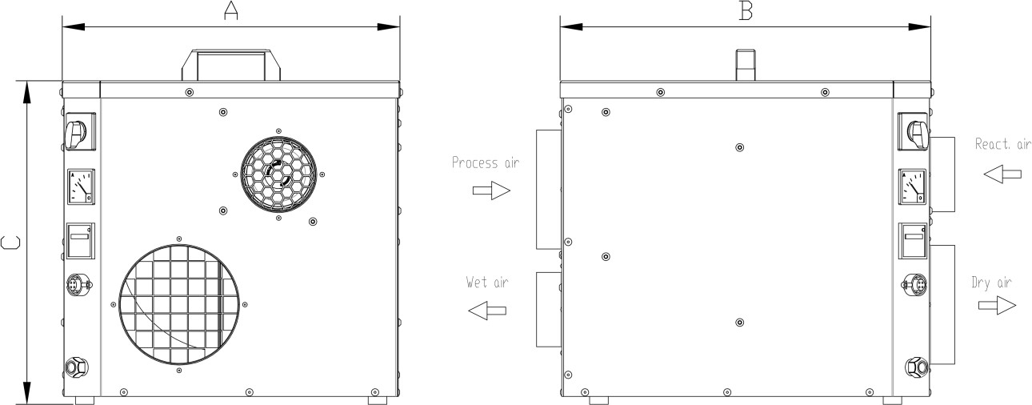
Dimensions

Model | AD | 100 | 270 | 420 | 550 | 700 | 820 | 1250
A | mm | 435 | 435 | 490 | 490 | 490 | 611 | 611
B | mm | 500 | 500 | 640 | 640 | 640 | 680 | 680
C | mm | 436 | 436 | 490 | 490 | 490 | 720 | 720
Empty weight | Kg | 25 | 26 | 31,5 | 31,5 | 33 | 57 | 62
Connections
Process air inlet | mm | Ø 160 | Ø 160 | Ø 200 | Ø 200 | Ø 200 | Ø 250 | Ø 250
Dry air outlet | mm | Ø 125 | Ø 125 | Ø 200 | Ø 200 | Ø 200 | Ø 200 | Ø 200
Regeneration air inlet | mm | Ø 125 | Ø 125 | Ø 160 | Ø 160 | Ø 160 | Ø 160 | Ø 160
Wet air outlet | mm | Ø 80 | Ø 80 | Ø 125 | Ø 125 | Ø 125 | Ø 160 | Ø 160

TECNOFRIGO TUSCANY srl WWW.TFTDRYAIR.COM
Via J.F.Kennedy, 25-27-29 INFO@TFTDRYAIR.COM
56020 Capanne (Pisa)
+39 0571 467351 CEN0112 issuance 07.20

