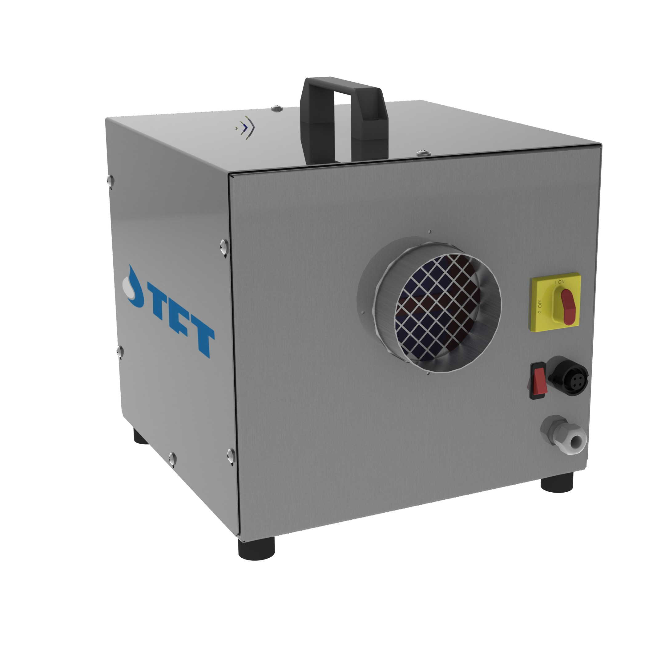

AIRDRY
Adsorption Dehumidifiers








TECHNICAL DATA
MODELLO | ADS | 150 | 300
Performances
Dehumidification Capacity * | Kg/h | 0,57 | 1,1
Fans
Process air flow | m³/h | 150 | 300
Static pressure | Pa | 100 | 150
Fan nominal power | W | 52 | 102
Regeneration air flow | m³/h | 50 | 100
Static pressure | Pa | 100 | 150
Fan nominal power | W | - | -
Drive Motor
Nominal power | VA | 3,7 | 3,7
Regeneration
Regereration type |  | Electric | Electric
Installed power | KW | 0,7 | 1,4
Temperature rise in the heating coil | °C | 80 | 80
Electrical characteristics
Power supply | Volt/Ph/Hz | 230/1+N/50 ±5% | 230/1+N/50 ±5%
Maximum power absorbed standard units | KW | 0,76 | 1,51
Maximum current absorbed standard units | A | 4 | 7
Noise level
Sound pressure ** | dB (A) | 42 | 42
Sound power ** | dB (A) | 70 | 70
* Alle condizioni di 20°C 60% UR
** Livello di pressione sonora calcolato in campo libero, a 10 metri dall’unità, fattore di direzionalità Q=2, secondo ISO 9614

CAPACITA’ DI DEUMIDIFICAZIONE
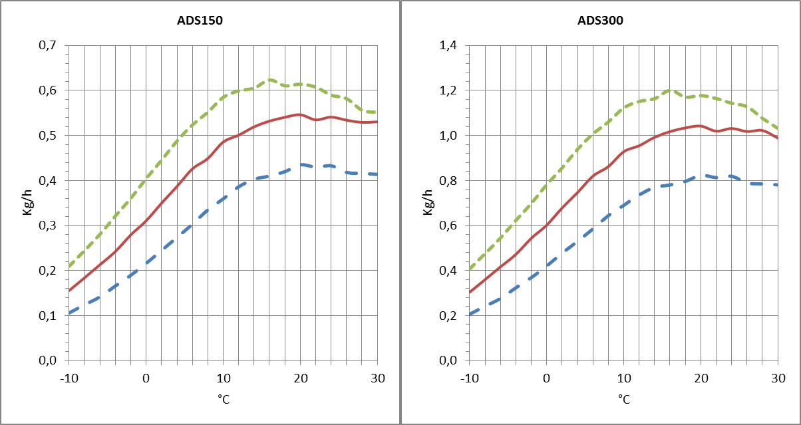
Capacità approssimativa in Kg/h con diversi valori di umidità relativa dell’aria di processo in ingresso (%UR).

TECNOFRIGO TUSCANY srl
Via J.F.Kennedy, 25-27-29
56020 Capanne (Pisa)
+39 0571 467351

PRINCIPLE OF OPERATION
WWW.TFTDRYAIR.COM INFO@TFTDRYAIR.COM

CEN0103 issuance 12.16
Subject to change without notice
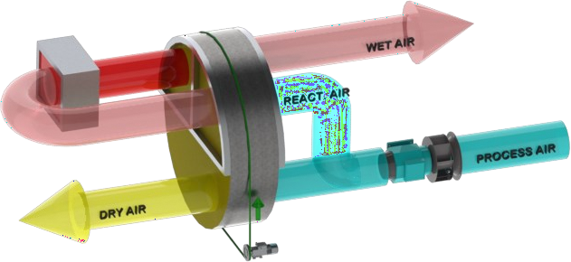
he dehumidifier works by using two streams of air; the main one consists of the air to be dehumi- dified, a second flow - of minor capacity - is instead used to regenerate the dehumidifying rotor. A fan inside the dehumidifier creates these two streams of air crossing the rotor in opposite directions. The air to dehumidify - also called "process air", crosses the silica gel impregnated drying rotor. Silica gel is a highly hygroscopic material that absorbs water vapor from the air. During the passage of the rotor, the air releases its moisture content to the rotor itself. The dehu- midified air is then sent to the production room or to the dehumidifying process. The dehumidifi- cation process can take place between temperatures between -30°C and +40°C. During the process the rotor rotates very slowly and is equipped with a transmission system with gear mo- tor and belt. The so-called "regeneration air" is used by the system to remove the absorbed moisture and bring it to the outside: it is heated by an internal dehumidifier battery up to about + 100 ° C and crosses the rotor in the opposite direction to the " process air and subject it to an inverse process for which the rotor sheds its moisture content and resets its initial absorbing capacity. Regeneration air is ejected warm and humid and must be sent out of the treated envi- ronment.

STRUCTURE
The structure of the dehumidifier is made of galvanized steel and steel AISI_304. The top panel can be removed for maintenance on electrical compo- nents and all other internal mechanical parts. The dehumidifier connections can be made with standard spiral ducts.

FANS
Fans are directly coupled to single-phase or three-phase motors rated at IP55, ISO F, class B. They are accessible for maintenance by removing the inspected top panel. The process and regenerator fans immediately start to dehumidify the system.

ROTOR
The desiccant rotor installed in the dehumidifier is the best currently available to the market, offering approximately 8% better moisture removal capacity and 25% less air pressure drop than the leading competitor. The rotor has a finely fluted structure manufactiured from corrugated and heat resistant material and offering a huge contact surface area for the process air stream in a very small volume. The fluted and laminar nature of the structure af- fords a high contact area with the passing air flow to maximise moisture removal.
The rotor is not affected by saturated air and can therefore be used in conjunction with a pre-cooling coil. Additionally, the rotor will not be damaged if either of the airflows stop for any reason. The rotor does not shed particles and will not support the spread of flame (non-combustible).

TRANSMISSION SYSTEM
A belt drive system is used to turn the rotor. This movement is typically between 6 and 12 rph, and uses a powerful direct drive motor and reduction gearbox, operating on a belt with frictional contact with the outer rim of the rotor drum. A belt tensioning system is used to maintain correct belt tension and avoid slip. The rotation of the rotor is visible by removal of the front access panel so correct operation can be determined. The rotor is suspended on ball bearings around a central steel shaft.

REGENERATION AIR HEATING COIL
Electrical. The electric regeneration battery has self-regulating PTC elements, with modulating power system to increase the efficiency of the dehu- midifier field and save energy.

FILTERS
The dehumidifier has two separate G2 filters: on the process air and regeneration air inlet.

ELECTRICAL PANEL
The electric panel is made in compliance with European regulations 73/23 and 89/336. Access to the electrical panel is possible by removing the top panel of the unit. In all units, the following components are installed as standard: main switch, ammeter, external connection humidifier connector. The panel is also equipped with a switch for manual or automatic dehumidification control.

VERSION
ADS… Standard
ADS…/M01 Construction version, with pivoting wheels and working hour meter

Model ADS | Code | 150 | 300
Painted steel frame |  | - | -
Satin stainless steel frame 304 |  | ● | ●
Construction site version with pivoting wheels | M01 | ○ | ○
Main power switch |  | ● | ●
Frame Handed version | M | - | -
Filters G2 process and reactivation |  | ● | ●
Filters F5, F7, F9 |  | - | -
Electronic PLC control and touch-screen terminal |  | - | -
Remote terminal | TR | - | -
Different power supply voltage |  | ○ | ○
Proportional control PWM regenerationheaters | PWM | - | -
Process filter alarm | ALFP | - | -
Regeneration filter alarm | ALFR | - | -
Mechanical humidistat for duct 30÷100% IP65 1 step | ADKM1 | ○ | ○
Mechanical humidistat for duct or wall 10÷100% IP54 1 step | ADKMH1 | ○ | ○
Mechanical humidistat for duct or wall 10÷100% IP54 2 steps | ADKMH2 | ○ | ○
Mechanical humidistat for wall 2 steps with duct probe temperature / relative humidity  range -30÷70°C / 0÷100% | ADKW + ADKH1 | ○ | ○
Electronic humidistat for wall 2 steps with duct probe temperature / relative humidity range  NTC / 10÷90% | ADKW + ADKH2 | ○ | ○
Electronic humidistat for wall 2 steps with wall probe temperature / relative humidity range  NTC / 10÷90% | ADKW +  ADKH3 | ○ | ○
- standard, ○ optional, – not available.

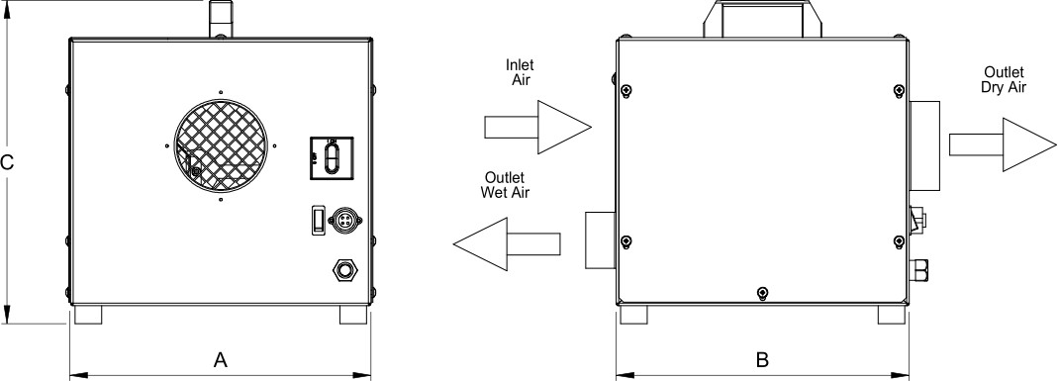
Dimensions
Model | ADS | 150 | 300
A | mm | 345 | 425
B | mm | 330 | 380
C | mm | 365 | 445
Empty weight | Kg | 12 | 16
Connections
Process and regeneration air inlet | mm | 130 x 130 | 130 x 130
Dry air outlet | mm | Ø 100 | Ø 160
Wet air outlet | mm | Ø 63 | Ø 80

TECNOFRIGO TUSCANY srl WWW.TFTDRYAIR.COM
Via J.F.Kennedy, 25-27-29 INFO@TFTDRYAIR.COM
56020 Capanne (Pisa)
+39 0571 467351 CIT1031 issuance 12.16
Subject to change without notice

