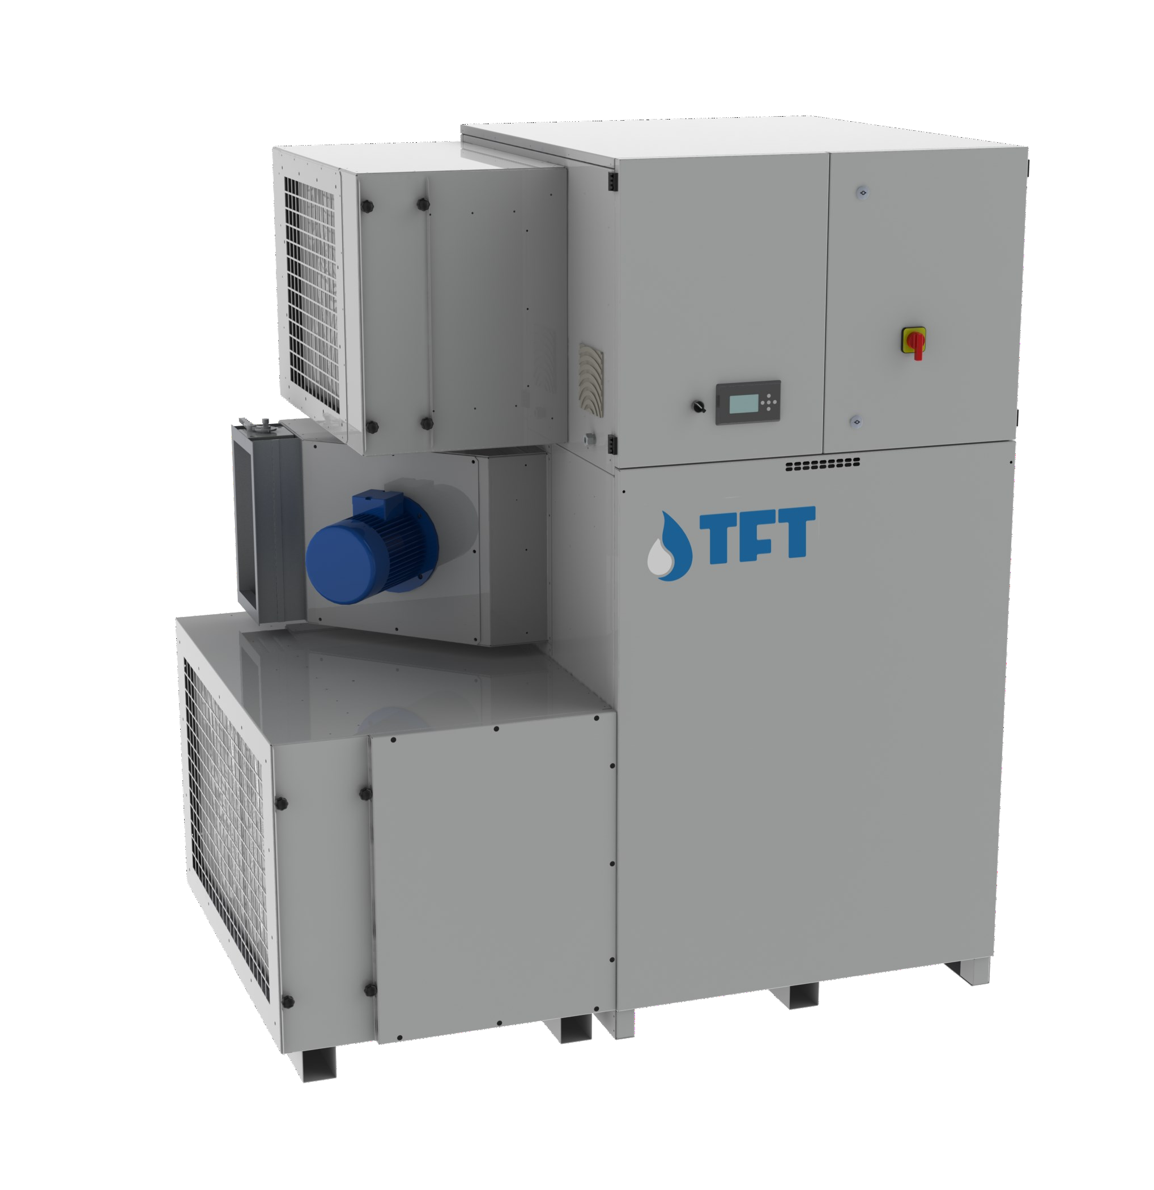

AIRDRY
Adsorption Dehumidifiers





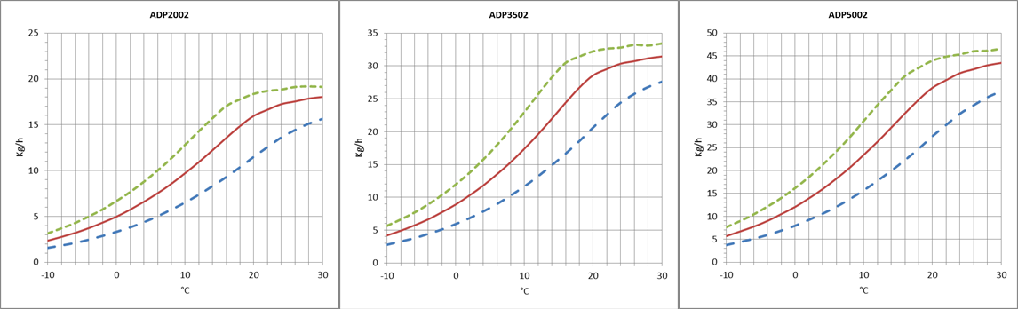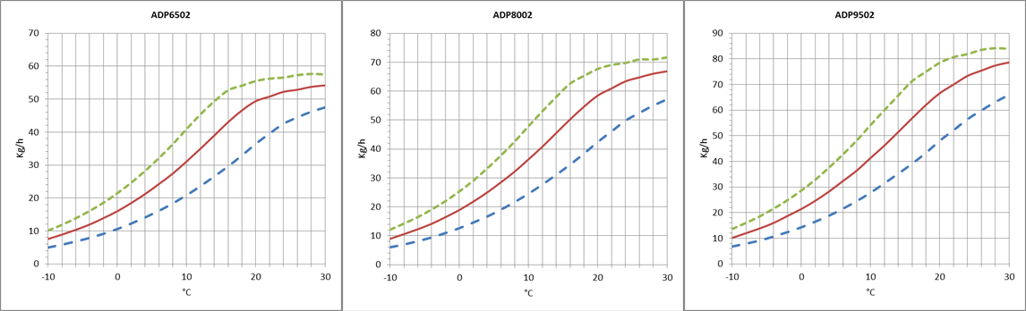
TECNOFRIGO TUSCANY srl
Via J.F.Kennedy, 25-27-29
56020 Capanne (Pisa)
+39 0571 467351

TECHNICAL DATA
MODEL | ADP | 2002 | 3502 | 5002 | 6502 | 8002 | 9502
Performances
Dehumidification Capacity * | Kg/h | 16,0 | 28,7 | 38,2 | 50,7 | 58,8 | 66,9
Fans
Process air flow | m³/h | 2000 | 3500 | 5000 | 6500 | 8000 | 9500
Static pressure | Pa | 400 | 400 | 400 | 400 | 400 | 400
Fan nominal power | KW | 1,1 | 2,2 | 3 | 4 | 5,5 | 7,5
Reactivation air flow | m³/h | 700 | 1200 | 1700 | 2200 | 2600 | 3100
Static pressure | Pa | 400 | 400 | 400 | 400 | 400 | 400
Fan nominal power | KW | 0,75 | 0,75 | 1,1 | 1,1 | 1,5 | 2,2
Drive Motor
Nominal power | W | 10 | 10 | 10 | 10 | 10 | 10
Regeneration
Regeneration type |  | Electrical | Electrical | Electrical | Electrical | Electrical | Electrical
Installed power | KW | 24 | 42 | 60 | 72 | 90 | 105
Regeneration type |  | Steam | Steam | Steam | Steam | Steam | Steam
Power output heating | KW | 24,1 | 41,4 | 58,6 | 75,9 | 89,7 | 106,9
Steam consuption at 6Bar(a) | Kg/h | 42 | 71 | 101 | 131 | 155 | 185
Temperature rise in the heating coil | °C | 100 | 100 | 100 | 100 | 100 | 100
Electrical characteristics
Power supply | Volt/Ph/Hz | 400/3/50 ±5% | 400/3/50 ±5% | 400/3/50 ±5% | 400/3/50 ±5% | 400/3/50 ±5% | 400/3/50 ±5%
Maximum power absorbed standard units | KW | 25,9 | 45 | 64,1 | 77,1 | 97 | 114,7
Maximum current absorbed standard units | A | 38,7 | 71,4 | 94,4 | 113,4 | 142,5 | 169,4
Noise level
Sound pressure ** | dB (A) | 60 | 64 | 65 | 66 | 69 | 70
Sound power ** | dB (A) | 88 | 92 | 93 | 94 | 97 | 98
* Conditions at 20°C 60% RH
** Sound pressure level calculated in free field, 10 meters from unit, direction factor Q = 2, according to ISO 9614

DEHUMIDIFICATION CAPACITY
Approximate capacity in Kg / h with different relative humidity values of inlet process air (RH%).

WWW.TFTDRYAIR.COM INFO@TFTDRYAIR.COM
CEN2095 issuance 02.19 Subject to change without notice

PRINCIPLE OF OPERATION
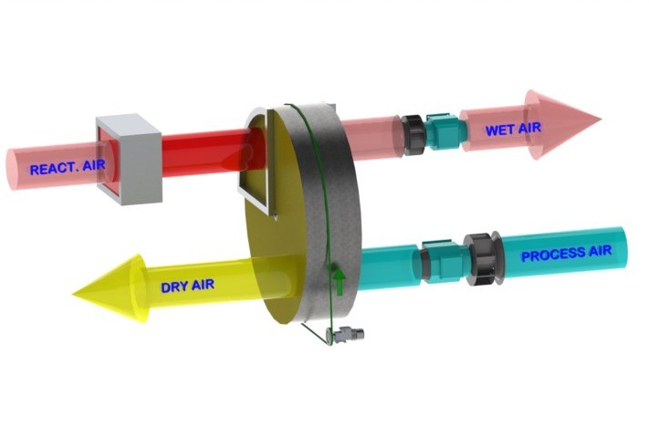
The dehumidifier works using two air flows; the main one is the air to be dehumidified, while a second flow - of lower flow rate - is used to regenerate the dehumidification rotor. Two fans inside the dehumidifier create these two air flows that cross the rotor in opposite directions. The air to be dehumidified, also called "process air", passes through the desiccant rotor impregnated with silica gel. Silica gel is a highly hygroscopic material that absorbs water vapour from the air. As it passes through the rotor, the air transfers its moisture content to the rotor itself. The dehu- midified air is then sent to the production room or process to be dehumidified. The dehumidifica- tion process can take place between -30°C and +40°C. During the process, the rotor rotates very slowly and is equipped with a drive system with a reduction gear and belt. The so-called "regeneration air", is used by the system to remove the absorbed moisture and take it outside: it is heated by a battery inside the dehumidifier, up to about +100°C and crosses the rotor in the opposite direction to the process air and submits it to a reverse process, for which the rotor gives up its moisture content and is restored to its initial absorption capacity. The regeneration air is expelled warm and humid and must be sent outside the treated environment.

STRUCTURE
The structure of the dehumidifier is made of painted galvanized steel and/or AISI304 steel with
sandwich panels. The upper panel can be removed for maintenance of the electrical components, while to access all the internal mechanical parts just remove the front panel. The connections to the dehumidifier can be made with standard spiral channels.

FANS
Fans are directly coupled to single-phase or three-phase motors rated at IP55, ISO F, class B. They are accessible for maintenance by removing a second internal panel so that in operation risk of injury is mitigated. The fans can be controlled by an optional frequency converter to control rotation speed and match performance with specific requirements. As standard, the process fan is set at fixed speed, but it can be configured to run at variable speeds from an external signal, or pressure sensor.

ROTOR
The dehumidifier has a rotor made of desiccant material. The rotor has an alveolar structure made of heat-resistant corrugated sheets containing the silica gel desiccant material, which creates a high number of axial fluid threads and at the same time a high absorption surface in a small volume. The rotor is constructed to withstand saturated air without being damaged, so it can be coupled with a pre-cooling coil. Furthermore, the rotor is not dama- ged if the process or regeneration fan should stop due to a fault during operation. The rotor is non-combustible and non-flammable.

TRANSMISSION SYSTEM
A belt drive system controls the movement of the rotor. The belt carries out its traction action on the outer edge of the rotor and is driven by a pulley on the gear motor. A special device maintains the correct tension of the belt to prevent slippage of the belt itself. The correct direction of rotation and tran- smission can be checked by opening the front panel. The rotor is equipped with ball bearings. The rotor shaft is made of steel.

REGENERATION AIR HEATING COIL
Electrical. The electric regeneration battery has steel elements, connected in a star and divided into 2, 3 or more groups for step regul ation with sequential insertion to have a power modulation. On request, continuous modulation (PWM) with proportional power control can be used to increa- se dehumidifier field efficiency and save energy.
Steam. The steam regeneration battery is built with stainless steel tubes304 and aluminium fins (versions with other materials can b e reque- sted as an option), and includes a 2-way valve (supplied as an option) with modulating servomotor, to ensure greater efficiency of the dehumidifier's output, acting on the steam flow rate.
Gas. The gas version is composed of a direct flame burner, with a gas ramp composed of minimum and maximum natural gas pressure con- trol valves and safety valve. In addition, the gas ramp is equipped with an adjustable valve with modulating servomotor, to ensure greater efficiency of the dehumidifier's output, acting on the flow of natural gas and consequently regulating the burner flame.

FILTERS
The dehumidifier has two separate G4 filters: one on the process air inlet and the other on the high temperature regeneration air inlet. On request, hi-
gher grade filters can be supplied.

PLC CONTROL WITH TOUCH-SCREEN TERMINAL
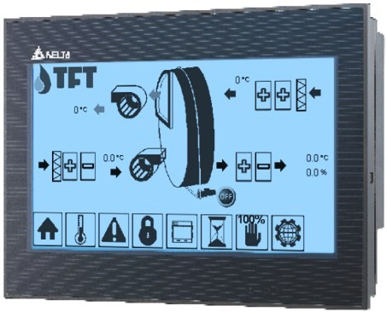
All standard units are supplied with PLC control and touch-screen terminal. The PLC controls the following functions: regeneration temperature control, thermal protection, post-cooling regeneration timing, component start sequence, alarm reset, moisture dehumidification/humidification control, pre- and post-cooling/heating control. The display for the user interface can be remotely controlled. The PLC is set up for step management from an external humidistat, and accepts analogue signals from humidity sensors. On request, the micropro- cessor can be connected to remote BMS control systems. The technical department is available to study, to- gether with the customer, different solutions using MODBUS protocols.

ELECTRICAL PANEL
The electrical panel is manufactured in compliance with European standards 73/23 and 89/336. The electrical panel is accessible from the front of the unit by means of a special key for opening. The following components
are installed in all the units as standard: main switch, thermal magnetic switches (to protect the fans and the electrical resistances), fan relays, gearmo- tor relays, electrical resistance relays (if present). The panel is also equipped with a terminal board with dry contacts for remote ON OFF control and dry contacts for general alarm.

TECNOFRIGO TUSCANY srl
Via J.F.Kennedy, 25-27-29
56020 Capanne (Pisa)
+39 0571 467351
WWW.TFTDRYAIR.COM INFO@TFTDRYAIR.COM
CEN2095 issuance 02.19 Subject to change without notice

VERSIONS
AD… Standard
AD…/TX Version with external satin stainless steel frame 304
AD…/TTX Version with steel frame completely inox304 interior and exterior satin AD…/STC Construction version, with pivoting wheels

Model AD | Codice | 2002 | 3502 | 5002 | 6502 | 8002 | 9502
Painted steel frame |  | ● | ● | ● | ● | ● | ●
Satin stainless steel frame 304 | TX | ○ | ○ | ○ | ○ | ○ | ○
Frame totally stainless steel304 and satin finish outside | TTX | ○ | ○ | ○ | ○ | ○ | ○
Construction site version with pivoting wheels | STC | ○ | ○ | ○ | ○ | ○ | ○
Frame Handed version | M | - | - | - | - | - | -
Filters G4 process and reactivation |  | ● | ● | ● | ● | ● | ●
Filters F5, F7, F9 |  | ○ | ○ | ○ | ○ | ○ | ○
Recovery regeneration heat | RCFX | ○ | ○ | ○ | ○ | ○ | ○
Purge area for low Dew Point | LDP | ○ | ○ | ○ | ○ | ○ | ○
Pre-cooling water coil | W | ○ | ○ | ○ | ○ | ○ | ○
Post-cooling water coil | PW | ○ | ○ | ○ | ○ | ○ | ○
Post-heating water coil | PHW | ○ | ○ | ○ | ○ | ○ | ○
Proportional 3way-valve for pre/post-treatments (supply only) | 3WSF | ○ | ○ | ○ | ○ | ○ | ○
Proportional 3way-val. for pre/post-treatments (with assembly) | 3WCM | ○ | ○ | ○ | ○ | ○ | ○
PLC electronic control and touch-screen display |  | ● | ● | ● | ● | ● | ●
Remote terminal | TR | ○ | ○ | ○ | ○ | ○ | ○
Different power supply voltage |  | ○ | ○ | ○ | ○ | ○ | ○
Proportional control PWM regenerationheaters | PWM | ● | ● | ● | ● | ● | ●
Proportional 2way-valve for steam regeneration | 2VS | ○ | ○ | ○ | ○ | ○ | ○
Process fan inverter (VFD) | VFP | ● | ● | ● | ● | ● | ●
Regeneration fan inverter (VFD) | VFR | ● | ● | ● | ● | ● | ●
Process filter alarm | ALFP | ○ | ○ | ○ | ○ | ○ | ○
Regeneration filter alarm | ALFR | ○ | ○ | ○ | ○ | ○ | ○
Circular spigot connections for processes/regeneration | CP | ○ | ○ | ○ | ○ | ○ | ○
Temperature sensor / RH%, Absolute Humidity, DewPoint | ST / H | ○ | ○ | ○ | ○ | ○ | ○
Serial RS485 ModBus Interface |  | ● | ● | ● | ● | ● | ●
TCP-IP ModBus Interface |  | ● | ● | ● | ● | ● | ●
Other protocols and other accessories on request |  | ○ | ○ | ○ | ○ | ○ | ○
- standard, ○ optional, – not available.

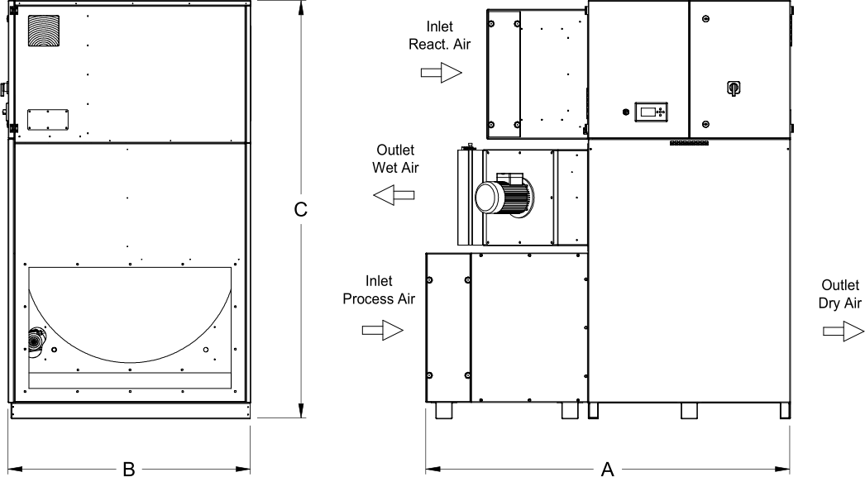
Dimensions

Model | AD | 2002 | 3502 | 5002 | 6502 | 8002 | 9502
A | mm | 1650 | 1750 | 1750 | 1850 | 1850 | 1850
B | mm | 1000 | 1150 | 1150 | 1250 | 1250 | 1250
C | mm | 1875 | 1975 | 1975 | 2075 | 2075 | 2075
Empty weight | Kg | 470 | 530 | 570 | 670 | 690 | 710
Connections
Process air inlet | mm | 850 x 500 | 950 x 600 | 950 x 600 | 1000 x 600 | 1000 x 600 | 1000 x 600
Dry air outlet | mm | 850 x 500 | 950 x 600 | 950 x 600 | 1000 x 600 | 1000 x 600 | 1000 x 600
Reactivation air inlet | mm | 600 x 400 | 600 x 400 | 600 x 400 | 600 x 400 | 600 x 400 | 600 x 400
Wet air outlet | mm | 370 x 200 | 370 x 200 | 370 x 200 | 370 x 200 | 370 x 200 | 370 x 200

