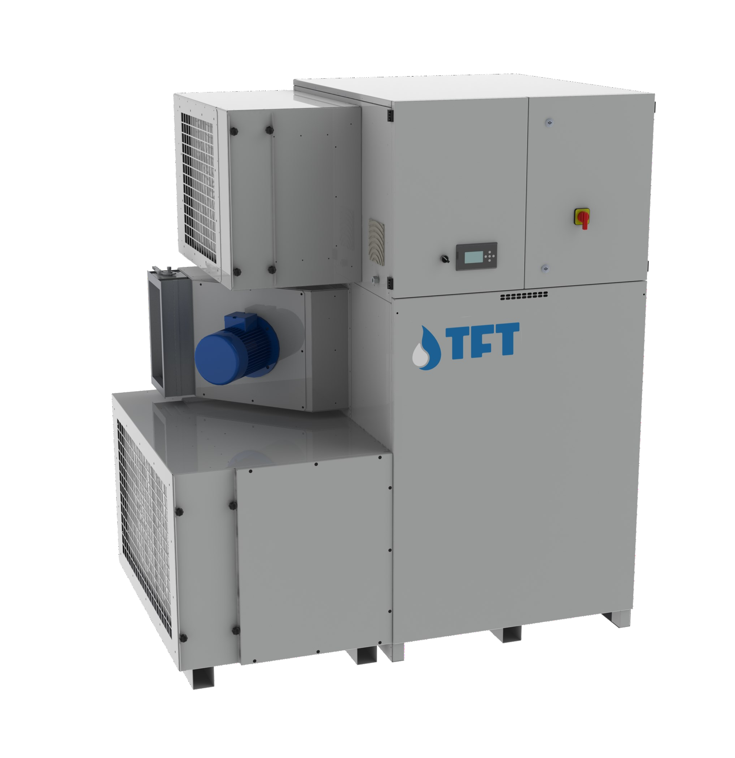

AIRDRY
Adsorption Dehumidifiers





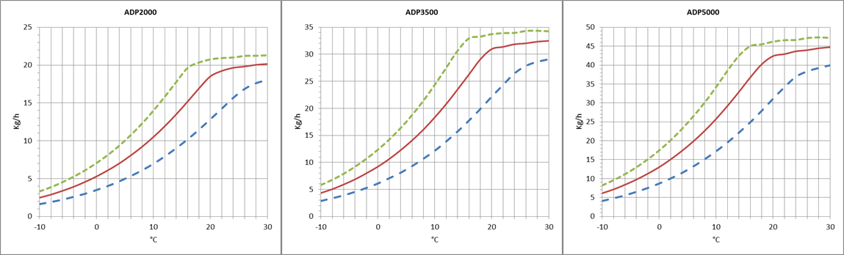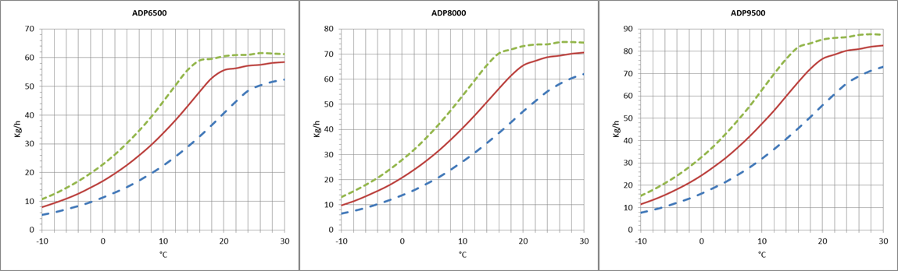

TECHNICAL DATA
MODEL | ADP | 2000 | 3500 | 5000 | 6500 | 8000 | 9500
Performances
Dehumidification Capacity * | Kg/h | 18,6 | 31,1 | 42,5 | 55,9 | 66,0 | 77,1
Fans
Process air flow | m³/h | 2000 | 3500 | 5000 | 6500 | 8000 | 9500
Static pressure | Pa | 400 | 400 | 400 | 400 | 400 | 400
Fan nominal power | KW | 1,1 | 1,5 | 2,2 | 4 | 5,5 | 7,5
Reactivation air flow | m³/h | 700 | 1200 | 1700 | 2200 | 2600 | 3100
Static pressure | Pa | 400 | 400 | 400 | 400 | 350 | 350
Fan nominal power | KW | 0,75 | 0,75 | 1,1 | 1,5 | 1,5 | 2,2
Drive Motor
Nominal power | W | 10 | 10 | 10 | 10 | 10 | 10
Regeneration
Regeneration type |  | Electrical | Electrical | Electrical | Electrical | Electrical | Electrical
Installed power | KW | 25,5 | 39,6 | 56,1 | 72,6 | 85,8 | 99,0
Regeneration type |  | Steam | Steam | Steam | Steam | Steam | Steam
Power output heating | KW | 24,2 | 41,2 | 58,6 | 75,5 | 89,7 | 106,5
Steam consuption at 6Bar(a) | Kg/h | 36 | 61 | 86 | 111 | 133 | 158
Temperature rise in the heating coil | °C | 100 | 100 | 100 | 100 | 100 | 100
Electrical characteristics
Power supply | Volt/Ph/Hz | 400/3/50 ±5% | 400/3/50 ±5% | 400/3/50 ±5% | 400/3/50 ±5% | 400/3/50 ±5% | 400/3/50 ±5%
Maximum power absorbed standard units | KW | 27,4 | 41,9 | 59,4 | 78,1 | 92,8 | 108,7
Maximum current absorbed standard units | A | 43,9 | 66,8 | 93,9 | 121,8 | 145,7 | 172,3
Noise level
Sound pressure ** | dB (A) | 60 | 64 | 65 | 66 | 69 | 70
Sound power ** | dB (A) | 88 | 92 | 93 | 94 | 97 | 98
* Conditions at 20°C 60% RH
** Sound pressure level calculated in free field, 10 meters from unit, direction factor Q = 2, according to ISO 9614

DEHUMIDIFICATION CAPACITY
Approximate capacity in Kg / h with different relative humidity values of inlet process air (RH%).

TECNOFRIGO TUSCANY srl
Via J.F.Kennedy, 25-27-29
56020 Capanne (Pisa)
+39 0571 467351

PRINCIPLE OF OPERATION
WWW.TFTDRYAIR.COM INFO@TFTDRYAIR.COM

CEN2095 issuance 04.17
Sobject to change without notice
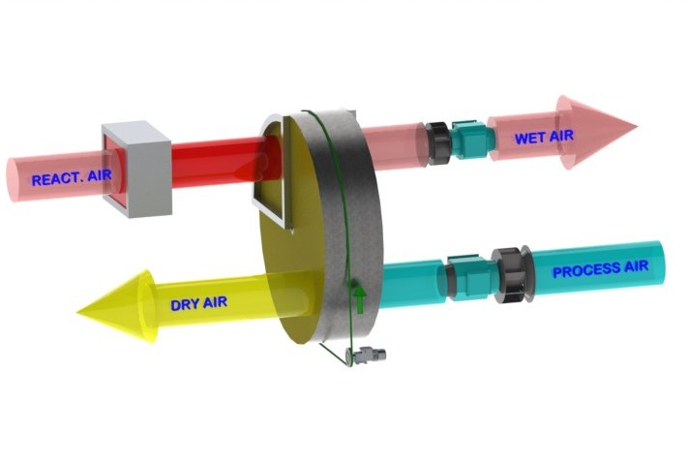
The dehumidifier operates with 2 airflows. The main airflow, the PROCESS AIR is what is dehu- midified and a second, smaller, airflow is used to regenerate the rotor material. Two high effi- ciency fan and motor assemblies inside the machine create these separate airflows in opposite directions through the rotor. The PROCESS AIR is taken trough the dehumidification rotor and moisture is taken up by the desiccant material bonded to the rotor structure. Mainly Silica Gel is used, which is a hygroscopic material capable of holding many times its weight in moisture, but always as a vapour and with no free water. As it passes through the rotor, the moisture in the air is absorbed by the Silica Gel and sent from the machine as a dry air stream for onward proces- sing, or direct to a conditioned room as required.
This dehumidification process is reliable between extremes of temperature, from as low as
-30°C and as high as +40°C.
During the process the rotor is turned very slowly by a small motor and reduction gearbox, dri- ving a belt with friction contact direct to the rotor surface.
The separate REGENERATION AIR stream is taken through the dehumidifier in the opposite direction, through a heater bank where the temperature is raised typically by +100°C above ambient. This heating increases the capacity of the air to hold moisture and as a result of the vapour pressure differentials between this air stream and the rotor surface, moisture is given back to the regeneration air stream and passed out of the building as a vapour.
The rotor is then ready to absorb more moisture as it is turned and the whole process can continue.

STRUCTURE
The dehumidifier casework is made from painted galvanized steel insulated sandwich panels as standard, or in AISI304 stainless steel if required by the process. The top panel is removeable for maintenance and access to electrical components whilst access to internal components is through the front. Connections for the airflows to and from the dehumidifier would typically be in standard galvanised spiral ducting.

FANS
Fans are directly coupled to single-phase or three-phase motors rated at IP55, ISO F, class B. They are accessible for maintenance by removing a second internal panel so that in operation risk of injury is mitigated. The fans can be controlled by an optional frequency converter to control rotation speed and match performance with specific requirements. As standard, the process fan is set at fixed speed, but it can be configured to run at variable speeds from an external signal, or pressure sensor.

ROTOR
The desiccant rotor installed in the dehumidifier is the best currently available to the market, offering approximately 8% better moisture removal capacity and 25% less air pressure drop than the leading competitor. The rotor has a finely fluted structure manufactiured from corrugated and heat resistant material and offering a huge contact surface area for the process air stream in a very small volume. The fluted and laminar nature of the structure af- fords a high contact area with the passing air flow to maximise moisture removal.
The rotor is not affected by saturated air and can therefore be used in conjunction with a pre-cooling coil. Additionally, the rotor will not be damaged if either of the airflows stop for any reason. The rotor does not shed particles and will not support the spread of flame (non-combustible).

TRANSMISSION SYSTEM
A belt drive system is used to turn the rotor. This movement is typically between 6 and 12 rph, and uses a powerful direct drive motor and reduction gearbox, operating on a belt with frictional contact with the outer rim of the rotor drum. A belt tensioning system is used to maintain correct belt tension and avoid slip. The rotation of the rotor is visible by removal of the front access panel so correct operation can be determined. The rotor is suspended on ball bearings around a central steel shaft.

REGENERATION AIR HEATING COIL
Electrical. The electric regeneration coil has steel elements, star connected, and divided into 2, 3 or more sequential control banks for power modulation. On demand, a continuous modulation with proportional power control can be used to increase the efficiency of the dehumidifier and save energy.
Steam. Steam regeneration coils are made of 304 grade stainless steel tubes with aluminium fins (options are available for other mat erials), and include a 2-port valve with modulating actuator to control the steam flow and thus the dehumidifier performance.

FILTERS
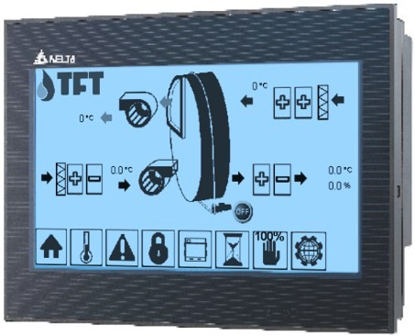
The dehumidifier has two separate G4 filters: one on the process air inlet and the other on the high temperature regeneration air inlet. On request, hi- gher grade filters can be supplied.

PLC CONTROL WITH TOUCH-SCREEN TERMINAL
All standard units are provided with PLC control. The PLC controls the following functions: regeneration tempe- rature regulation, thermal protection, regeneration cool down timing, component start sequence, alarm resets, RH or dewpoint control (dependant on control required) and control of pre and post-cooling or heating. The user interface display can be positioned remotely. The PLC is set for heater control from an external humidistat. On request, it can be adapted for connection to remote BMS systems. Operation with various MODBUS proto- cols can be discussed with the technical department if this is what is required by the process.

ELECTRICAL PANEL
The electric panel is made in compliance with European regulations 73/23 and 89/336. Access to the electrical panel is from the top after the panel is removed. All units include the following components as standard: mains switch, magneto thermal switches (for fan and electric resistance protection), fan relays, gearmotor relays and electric resistance relays (if any). The panel is also equipped with a terminal block with clean contacts for remote ON- OFF control and clean contact for general alarm.

VERSIONS
AD… Standard
AD…/TX Version with external satin stainless steel frame 304
AD…/TTX Version with steel frame completely inox304 interior and exterior satin AD…/STC Construction version, with pivoting wheels

Model AD | Codice | 2000 | 3500 | 5000 | 6500 | 8000 | 9500
Painted steel frame |  | ● | ● | ● | ● | ● | ●
Satin stainless steel frame 304 | TX | ○ | ○ | ○ | ○ | ○ | ○
Frame totally stainless steel304 and satin finish outside | TTX | ○ | ○ | ○ | ○ | ○ | ○
Construction site version with pivoting wheels | STC | ○ | ○ | ○ | ○ | ○ | ○
Frame Handed version | M | - | - | - | - | - | -
Filters G4 process and reactivation |  | ● | ● | ● | ● | ● | ●
Filters F5, F7, F9 |  | ○ | ○ | ○ | ○ | ○ | ○
Recovery regeneration heat | RCFX | ○ | ○ | ○ | ○ | ○ | ○
Purge area for low Dew Point | LDP | ○ | ○ | ○ | ○ | ○ | ○
Pre-cooling water coil | W | ○ | ○ | ○ | ○ | ○ | ○
Post-cooling water coil | PW | ○ | ○ | ○ | ○ | ○ | ○
Post-heating water coil | PHW | ○ | ○ | ○ | ○ | ○ | ○
Proportional 3way-valve for pre/post-treatments (supply only) | 3WSF | ○ | ○ | ○ | ○ | ○ | ○
Proportional 3way-val. for pre/post-treatments (with assembly) | 3WCM | ○ | ○ | ○ | ○ | ○ | ○
PLC electronic control and touch-screen display |  | ● | ● | ● | ● | ● | ●
Remote terminal | TR | ○ | ○ | ○ | ○ | ○ | ○
Different power supply voltage |  | ○ | ○ | ○ | ○ | ○ | ○
Proportional control PWM regenerationheaters | PWM | ● | ● | ● | ● | ● | ●
Proportional 2way-valve for steam regeneration | 2VS | ○ | ○ | ○ | ○ | ○ | ○
Process fan inverter (VFD) | VFP | ● | ● | ● | ● | ● | ●
Regeneration fan inverter (VFD) | VFR | ● | ● | ● | ● | ● | ●
Process filter alarm | ALFP | ○ | ○ | ○ | ○ | ○ | ○
Regeneration filter alarm | ALFR | ○ | ○ | ○ | ○ | ○ | ○
Circular spigot connections for processes/regeneration | CP | ○ | ○ | ○ | ○ | ○ | ○
Temperature sensor / RH%, Absolute Humidity, DewPoint | ST / H | ○ | ○ | ○ | ○ | ○ | ○
Serial RS485 ModBus Interface |  | ● | ● | ● | ● | ● | ●
TCP-IP ModBus Interface |  | ● | ● | ● | ● | ● | ●
Other protocols and other accessories on request |  | ○ | ○ | ○ | ○ | ○ | ○
- standard, ○ optional, – not available.

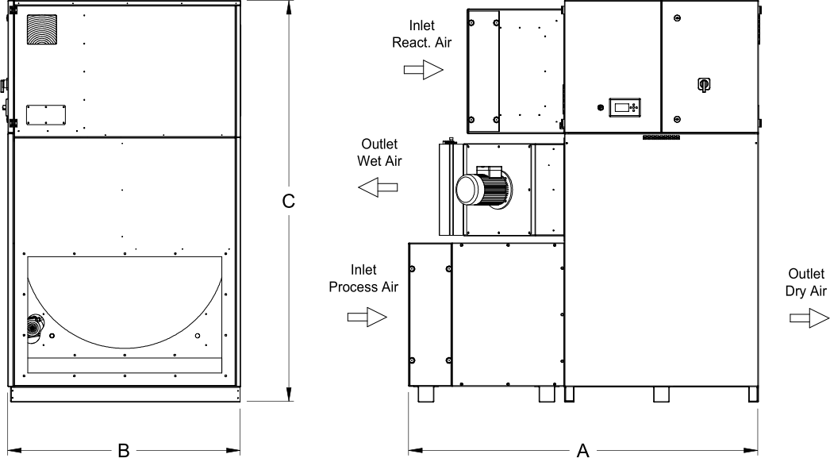
Dimensions

Model | AD | 2000 | 3500 | 5000 | 6500 | 8000 | 9500
A | mm | 1610 | 1710 | 1710 | 1810 | 1810 | 1810
B | mm | 1000 | 1100 | 1100 | 1200 | 1200 | 1200
C | mm | 1875 | 1975 | 1975 | 2075 | 2075 | 2075
Empty weight | Kg | 490 | 550 | 590 | 690 | 710 | 730
Connections
Process air inlet | mm | 850 x 500 | 950 x 600 | 950 x 600 | 1000 x 600 | 1000 x 600 | 1000 x 600
Dry air outlet | mm | 850 x 500 | 950 x 600 | 950 x 600 | 1000 x 600 | 1000 x 600 | 1000 x 600
Reactivation air inlet | mm | 600 x 400 | 600 x 400 | 600 x 400 | 600 x 400 | 600 x 400 | 600 x 400
Wet air outlet | mm | 370 x 200 | 370 x 200 | 370 x 200 | 370 x 200 | 370 x 200 | 370 x 200

TECNOFRIGO TUSCANY srl WWW.TFTDRYAIR.COM
Via J.F.Kennedy, 25-27-29 INFO@TFTDRYAIR.COM
56020 Capanne (Pisa)
+39 0571 467351 CEN2095 issuance 04.17
Sobject to change without notice

