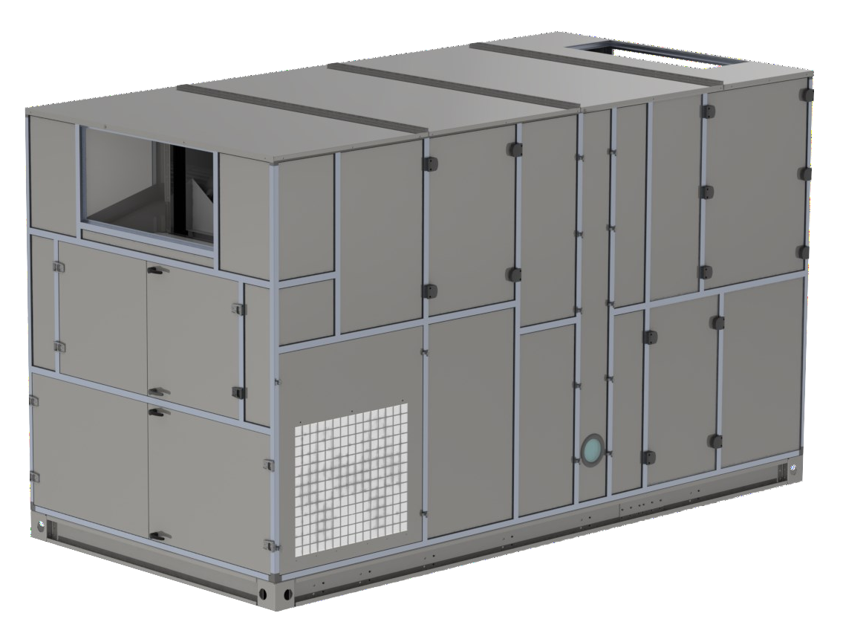AIRDRY
Dehumidifiers ECOAD





TECHNICAL DATA
MODEL | ADE | 2500 | 4000 | 6000 | 9000 | 11000 | 15000 | 19000
Performances
Dehumidification Capacity * | Kg/h | 18,2 | 28,5 | 39,6 | 56,8 | 70,0 | 94,3 | 119,2
Fans
Process air flow | m³/h | 2500 | 4000 | 6000 | 9000 | 11000 | 15000 | 19000
Static pressure | Pa | 350 | 350 | 350 | 350 | 350 | 350 | 350
Fan nominal power | KW | 1,1 | 2,2 | 3 | 5,5 | 5,5 | 7,5 | 11
Minimum regenerationair flow | m³/h | 2000 | 3000 | 4000 | 5500 | 7000 | 9000 | 11000
Maximum regenerationair flow | m³/h | 4500 | 7500 | 11000 | 15000 | 19000 | 22000 | 26000
Static pressure | Pa | 350 | 350 | 350 | 350 | 350 | 350 | 350
Fan nominal power | KW | 3 | 5,5 | 11 | 11 | 15 | 15 | 18,5
Drive Motor
Nominal power | W | 10 | 10 | 10 | 10 | 10 |  | 10
Compressor
Compressor type |  | reciprocating | reciprocating | reciprocating | reciprocating | reciprocating | reciprocating | reciprocating
Nominal absorbed power | KW | 5,5 | 8,0 | 12,1 | 17,3 | 19,5 | 27,5 | 33,0
Inrush current | A | 63 | 75 | 118 | 144 | 159 | 215 | 326
Gas refrigerant type |  | R134a | R134a | R134a | R134a | R134a | R134a | R134a
Electrical characteristics
Power supply | Volt/Ph/Hz | 400/3/50 ±5%
Maximumpower absorbed unit std | KW | 9,65 | 15,7 | 26,1 | 33,8 | 40,0 | 50,0 | 62,6
Maximum current absorbed unit std | A | 21,7 | 36,1 | 55,4 | 67,5 | 81,2 | 99,3 | 133,9
Noise level
Sound pressure ** | dB (A) | 71 | 72 | 74 | 74 | 76 | 78 | 78
Sound power ** | dB (A) | 99 | 100 | 102 | 102 | 104 | 106 | 106
* At 20°C 60% RH, maximum outdoor air temperature 35°C 50%
** Sound pressure level calculated in free field, 10 meters from unit, direction factor Q = 2, according to ISO 9614

TECNOFRIGO TUSCANY srl
Via J.F.Kennedy, 25-27-29
56020 Capanne (Pisa)
+39 0571 467351

PRINCIPLE OF OPERATION
WWW.TFTDRYAIR.COM INFO@TFTDRYAIR.COM

CEN25190 issuance 01.18
Subject to change without notice
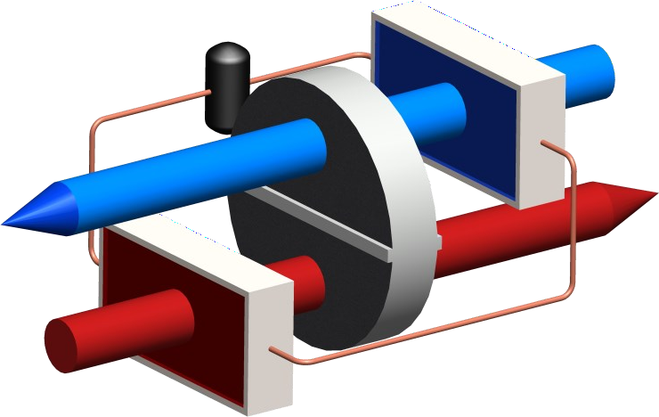
The dehumidifier works by using two air flows; the main one consists of the air to be dehumi- dified, a second flow is instead used to regenerate the dehumidification rotor. Two fans inside the dehumidifier create these two air flows that cross the rotor in opposite directions. The air to be dehumidified, also called "process air", passes through a cooling exchanger and the desiccant rotor impregnated with silica gel. Silica gel is a highly hygroscopic material that absorbs water vapor from the air. When passing through the exchanger and the rotor, the air gives off its moisture content. The dehumidified air is then sent to the production room or to the dehumidifying process. The dehumidification process can take place between temperatu- res between +15°C and +40°C. During the process the rotor rotates very slowly and is equip- ped with a transmission system with reduction gear and belt. The so-called "regeneration air", is used by the system to remove the absorbed moisture and take it outside: it is heated by means of a heat exchanger inside the dehumidifier, up to about +60°C and crosses the rotor in the opposite direction to the process air and subject it to an inverse process, for which the rotor transfers its moisture content and its initial absorbing capacity is restored. The regenera- tion air is expelled lukewarm and humid and must be sent to the treated environment.

STRUCTURE
The structure of the dehumidifier is made of aluminum profiles and sandwich panels in pain-
ted galvanized steel and / or AISI304 steel. The electrical panel is accessible from the outside with a lockable opening for maintenance of the electrical components, while to access all the mechanical internal parts, just remove the front panels. The connections to the dehumidifier can be made with channels.

FANS
Fans are directly coupled to single-phase or three-phase motors rated at IP55, ISO F, class B. They are accessible for maintenance by removing a second internal panel so that in operation risk of injury is mitigated. The fans can be controlled by an optional frequency converter to control rotation speed and match performance with specific requirements. As standard, the process fan is set at fixed speed, but it can be configured to run at variable speeds from an external signal, or pressure sensor.

ROTOR
The dehumidifier has a rotor made with desiccant material. The rotor has a honeycomb structure made of corrugated and heat-resistant sheets that contain the silica gel desiccant material, which creates a large number of axial fluid threads and at the same time a high absorption surface in a small volume. The rotor is constructed to withstand saturated air without being damaged, so it can be paired with a pre-cooling coil. Furthermore, the rotor will not be damaged if the process or regeneration fan were to stop due to malfunction during operation. The rotor is non-combustible and non-flammable.

COMPRESSOR
The compressors used are of the semi-hermetic reciprocating type, with crankcase heater, thermal overload protection in the motor winding. They are also equipped with protections for high and low pressure refrigerant circuit. Complete with continuous capacity partitioning system, for a better system efficiency.

TRANSMISSION SYSTEM
A belt drive system is used to turn the rotor. This movement is typically between 6 and 12 rph, and uses a powerful direct drive motor and reduction gearbox, operating on a belt with frictional contact with the outer rim of the rotor drum. A belt tensioning system is used to maintain correct belt tension and avoid slip. The rotation of the rotor is visible by removal of the front access panel so correct operation can be determined. The rotor is suspended on ball bearings around a central steel shaft.

REGENERATION COILS (Optional)
Electrical. The supplemental electric regeneration battery, has steel elements, connected to the star and divided into 2, 3 or more group s for step regulation with sequential insertion to have a modulation of the power. On request, continuous modulation (PWM) with proportional power control can be used to increase the efficiency of the dehumidifier field and save energy.
Steam. The supplemental steam regeneration battery is made of 304 stainless steel pipes and aluminum fins (optional versions with ot her materials can be requested), and includes a 2-way valve (supplied as an option) with a modulating servomotor, to guarantee greater efficiency of the dehumidifier output, acting on the steam flow rate.

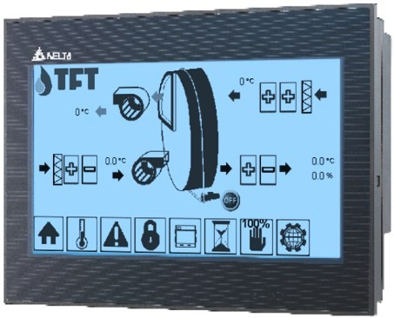
HEATING AND COOLING COILS
The heating coil (condenser) and the cooling coil (evaporator) are made of copper pipes and aluminum fins, as an option they can be made with other materials, such as stainless steel304, inox316, etc.

FILTERS
The dehumidifier has two separate G4 filters: one on the process air inlet and the other on the high temperature regeneration air inlet. On request, higher grade filters can be supplied.

PLC CONTROL WITH TOUCH-CREEN TERMINAL
All standard units are provided with PLC control. The PLC controls the following functions: regeneration tempe-
rature regulation, thermal protection, regeneration cool down timing, component start sequence, alarm resets, RH or dewpoint control (dependant on control required) and control of pre and post-cooling or heating. The user interface display can be positioned remotely. The PLC is set for heater control from an external humidistat. On request, it can be adapted for connection to remote BMS systems. Operation with various MODBUS protocols can be discussed with the technical department if this is what is required by the process.

ELECTRICAL PANEL
The electric panel is made in compliance with European regulations 73/23 and 89/336. Access to the electrical panel is from the top after the panel is removed. All units include the following components as standard: mains switch, magneto thermal switches (for fan and electric resistance protection), fan relays, gearmotor relays and electric resistance relays (if any). The panel is also equipped with a terminal block with clean contacts for remote ON- OFF control and clean contact for general alarm.

VERSIONS
ADE… Standard
ADE…/TX Version with external satin stainless steel frame 304
ADE…/TTX Version with steel frame completely inox304 interior and exterior satin ADE…/M Handed version (Process and Regeneration airflows are reversed)

Model ADE | Code | 2500 | 4000 | 6000 | 9000 | 11000 | 16000 | 19000
Painted steel frame |  | ● | ● | ● | ● | ● | ● | ●
Satin stainless steel frame 304 | TX | ○ | ○ | ○ | ○ | ○ | ○ | ○
Frame totally stainless steel304 and satin finish outside | TTX | ○ | ○ | ○ | ○ | ○ | ○ | ○
Frame Handed version | M | ○ | ○ | ○ | ○ | ○ | ○ | ○
Filters G4 process and reactivation |  | ● | ● | ● | ● | ● | ● | ●
Filtri F5, F7, F9 |  | ○ | ○ | ○ | ○ | ○ | ○ | ○
Recovery regeneration heat | RCFX | ○ | ○ | ○ | ○ | ○ | ○ | ○
Additional electric regeneration coils | RE | ○ | ○ | ○ | ○ | ○ | ○ | ○
Additional steam regeneration coils | RV | ○ | ○ | ○ | ○ | ○ | ○ | ○
PLC electronic control and touch-screen display |  | ● | ● | ● | ● | ● | ● | ●
Remote terminal | TR | ○ | ○ | ○ | ○ | ○ | ○ | ○
Different power supply voltage |  | ○ | ○ | ○ | ○ | ○ | ○ | ○
Proportional 2way-valve for steam regeneration | 2VS | ○ | ○ | ○ | ○ | ○ | ○ | ○
Process fan inverter (VFD) | VFP | ● | ● | ● | ● | ● | ● | ●
Regeneration fan inverter (VFD) | VFR | ● | ● | ● | ● | ● | ● | ●
Process filter alarm | ALFP | ○ | ○ | ○ | ○ | ○ | ○ | ○
Regeneration filter alarm | ALFR | ○ | ○ | ○ | ○ | ○ | ○ | ○
Temperature sensor / RH%, Absolute Humidity, DewPoint | ST / H | ○ | ○ | ○ | ○ | ○ | ○ | ○
Serial RS485 ModBus Interface |  | ● | ● | ● | ● | ● | ● | ●
TCP-IP ModBus Interface |  | ● | ● | ● | ● | ● | ● | ●
Other protocols and other accessories on request |  | ○ | ○ | ○ | ○ | ○ | ○ | ○
- standard, ○ optional, – not available.

TECNOFRIGO TUSCANY srl WWW.TFTDRYAIR.COM
Via J.F.Kennedy, 25-27-29 INFO@TFTDRYAIR.COM
56020 Capanne (Pisa)
+39 0571 467351 CEN25190 issuance 01.18
Subject to change without notice

